24-Jul-23

Vines and Wines

a card game for two to four players by Paul Owen

*Players represent vintners racing to expand their wineries, grow Grapes, and make and deliver Wine.*

# Introduction

In *Vines and Wines*, players take turns to draw cards from the center of the table into their Hands and play cards from their Hands to create their respective Tableaus of Buildings, Vines, Grapes, and Wine that together represent their wineries. Vines yield Grapes, which will improve with time and from which players can make Wine. The Wine will improve with age, and players can deliver the Wine to score points. When any player reaches 31 points, players finish out the round, and the one with the highest score wins.

Each player will play cards in front of themselves into their own Tableau that represents their winery. Each card can represent one of two features of the winery. An illustration and sometimes text in its center represents one feature – a Vine, Building, or Assistant. Icons and numbers in the corners together represent the other feature – Grapes or Wine. Which feature a card represents depends on its orientation at the time it is played to the table. A card played “right side up” as viewed by the player, or with its bottom edge parallel to the edge of the table (that is, “orthogonally”), represents the feature indicated by the illustration and text in the center of the card; the icons and numbers in its corners are ignored. On the other Hand, a card played with one corner of the card “right side up” as viewed by the player, in the manner of a diamond (that is, “diagonally”), is used for the purpose indicated by the icon and number that are in the corner right-side up to the player.

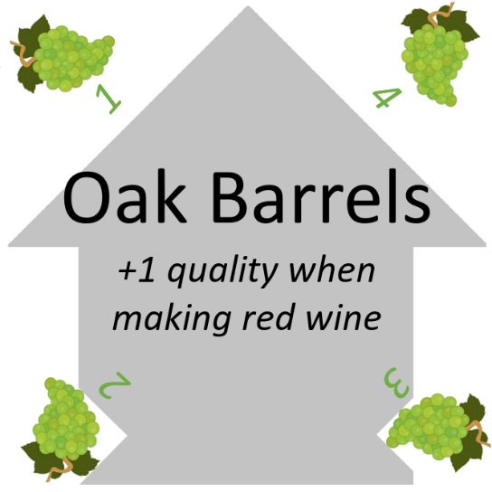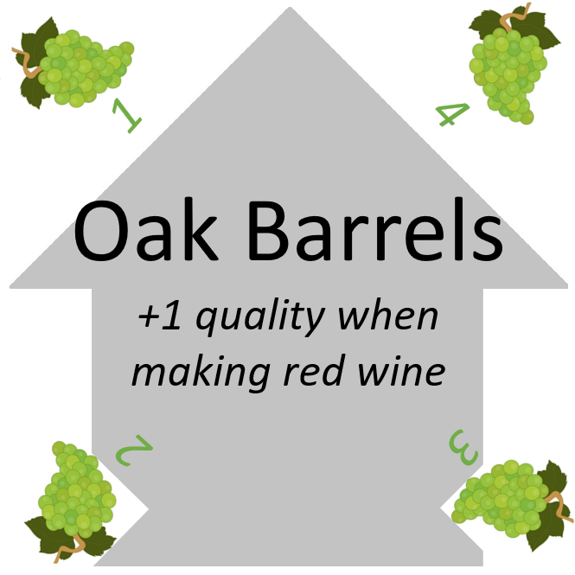

This card in an “Orthogonal” orientation represents a Building called “Oak Barrels: *+1 Quality when making Red Wine*.” (The Grapes in the corners are ignored.)

The same card in a “Diagonal” orientation represents a “White Grape” of Quality = 1. (The Oak Barrels Building is ignored. The grapes in the other three corners can come into play later.)

Cards with a “house” background (like “Oak Barrels” in the figure above) are Buildings that represent persistent improvements to a winery. Cards with a large red or white Vine illustration are Vines, also persistent additions to the winery, from which players can harvest Grapes. Cards with a “person” silhouette are Assistants that represent one-time bonuses.

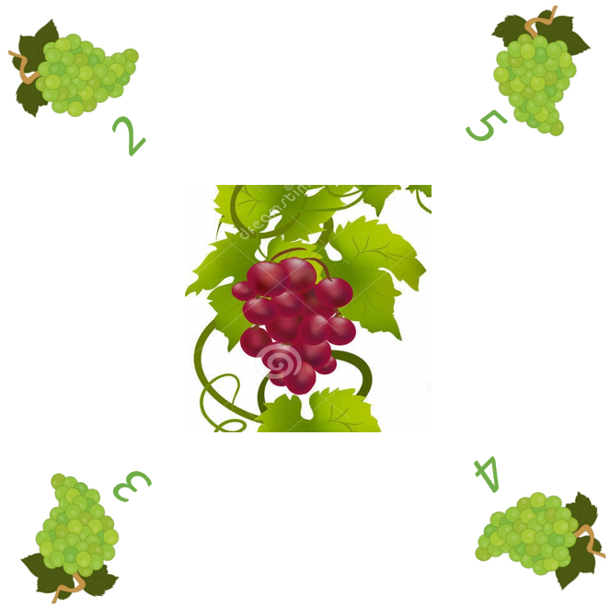 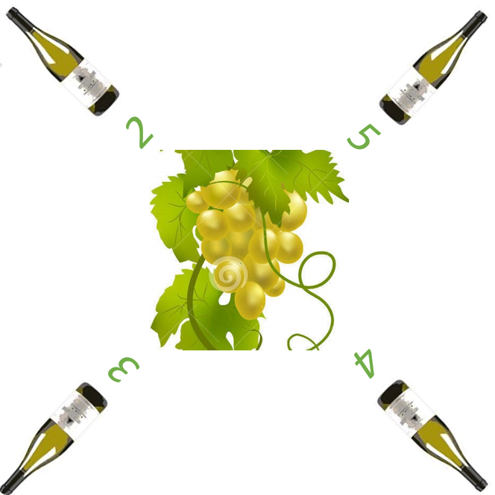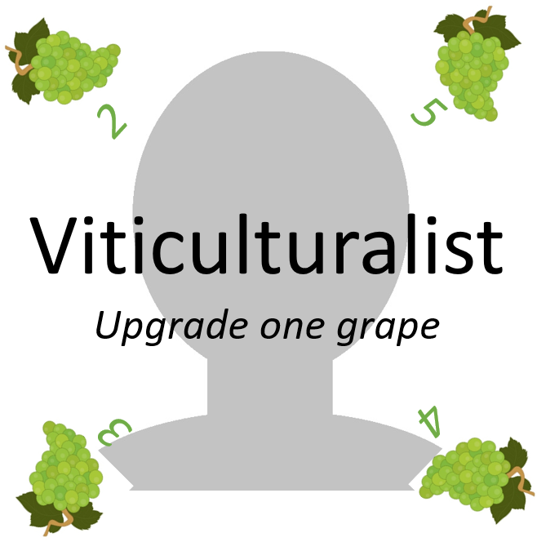

Red Vine

White Vine

Assistant

In their corners, cards can have red or White Grapes or red, white, or blush Wines.

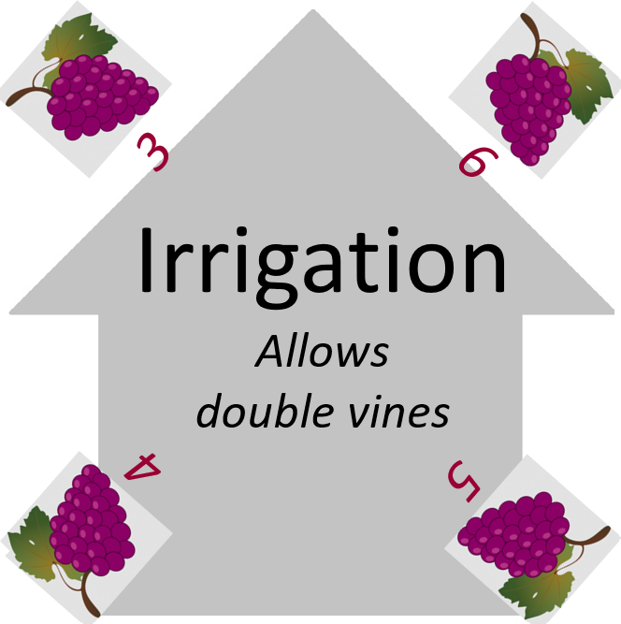

White Grape of Quality = 1 Red Grape of Quality = 3

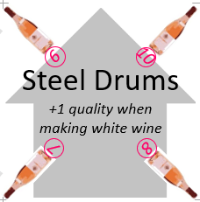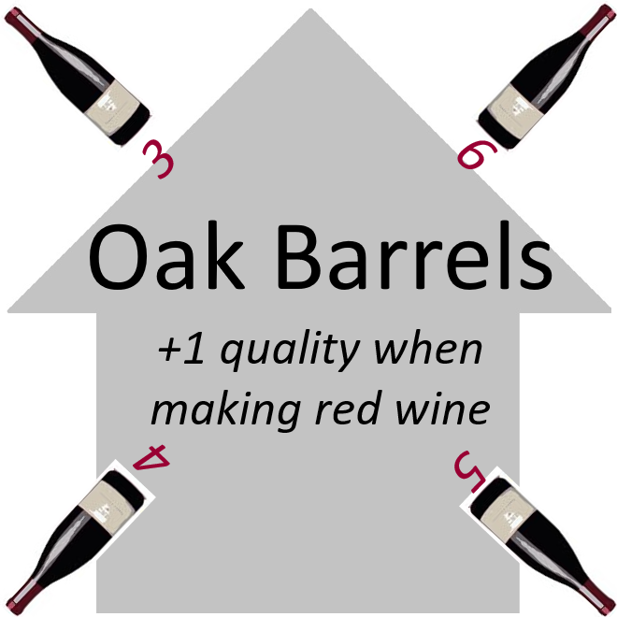

White Wine of Quality = 2 Red Wine of Quality = 3 Blush Wine of Quality = 6

Note that there is no relationship between whether a card has a red or white Vine in the center and red or White Grapes or Wine in the corners. A card can only serve one purpose when it is played, and the other illustrations or iconography are ignored.

# Setup

Each player takes a Starting White Vine, recognizable by the absence of icons in the corners, and places it on the table in front of them to start their Tableau, which will represent their winery.

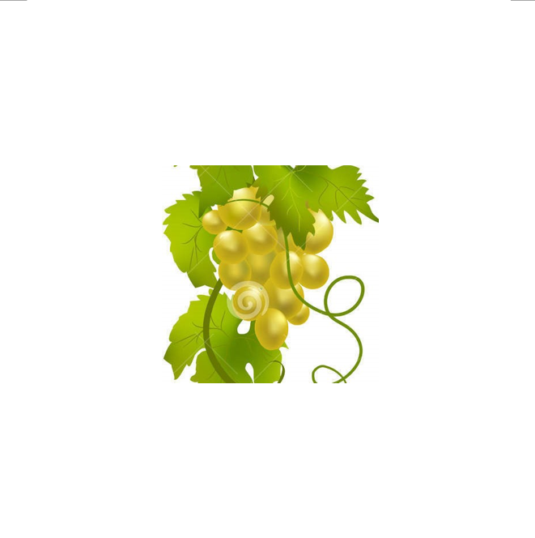

Starting White Vine

One player, designated the Dealer, shuffles the deck and deals five cards to each player face down. Each player may look at their Hand of cards privately.

The Dealer places the deck face down near the center of the table to form a Draw Pile, within reach of all players, and from the top of the Draw Pile lays out a row of five cards face up. These five cards form an Array from which players may draw cards during their turn. Whenever a card is taken from the Array, it is immediately replaced by a card from the top of the Draw Pile. During play, cards may be discarded into a face-up Discard Pile next to the Draw Pile. If the Draw Pile is ever exhausted, the Dealer shuffles the Discard Pile and places it face down to form a new Draw Pile.

# Gameplay

Starting with the player to the left of the Dealer, each player will take a turn consisting of the following steps:

1. Take any two actions from the following list:
   1. Draw a card.
   2. Plant a Vine.
   3. Harvest Grapes.
   4. Make Wine.
   5. Deliver Wine.
   6. Construct a Building.
   7. Play an Assistant.
   8. Sell Grapes.
   9. Replace Grapes or Wine.
2. Upgrade any eligible Grapes and Vines in their Tableau.
3. Discard cards down to no more than 14 cards total in their Hand and their Tableau.

Play continues to the left, each player taking a turn until one player has scored 31 points. If that player is the Dealer, then the Dealer wins; otherwise, play continues until the Dealer has taken a turn, at which point the player with the most points wins.

## Take two actions

The player takes any two actions from the following list. They can be in any order, and a player can take the same action twice:

### Draw a card

The player draws a card from the Array or from the top of the Draw Pile into their Hand. If the card was drawn from the Array, it is immediately replaced by a card from the top of the Draw Pile so that there are always five cars in the Array.

### Plant a Vine.

The player places a Vine card from their Hand face up into their Tableau in an orthogonal (“right side up”) orientation. The player may only plant a Double Vine card – a Vine card with two red and/or white Vine illustrations – if they already have an “Irrigation” Building in their Tableau.

### Harvest Grapes.

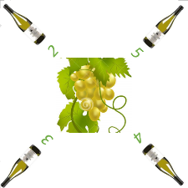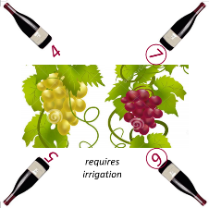The player places a Grape card from their Hand face up in their Tableau in a diagonal orientation such that the Quality of the Grape (the number underneath the Grape icon) is equal to or less than the number of Vines of the corresponding type (red or white) in their Tableau. Note that the number of Vines is based on the number of illustrations (rather than the number of Vine cards), so that a Double White Vine, for example, counts as two White Vines toward the maximum Quality White Grape that may be harvested. Multiple Grapes may be harvested from the same Vines as separate actions.

### Make Wine.

The player discards a Red or White Grape card from their Tableau and replaces it from their Hand with a Wine card of the same type and oriented diagonally to the same or lower Quality (the number underneath the Wine icon) as the discarded Grape card. Note that if the player already has a Wine of Quality 6 or higher in their Tableau but not a “Cellar,” then the maximum Quality Wine they can make is Quality 5.

Alternatively, the player may discard a Red Grape card and a White Grape card from their Tableau and replace them with a single Blush Wine card oriented diagonally to a Quality that is the same as or lower than the sum of the discarded Red and White Grapes, subject to the restriction on Wines of Quality 6 or higher.

### Deliver Wine.

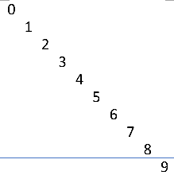The player discards a Wine card from their Tableau and scores a number of points equal to the Quality of the discarded Wine. Players may keep track of their points using the point tracker cards or by any other mutually agreeable method.

### Construct a Building.

The player discards two cards from their Hand to the Discard Pile and plays a Building card from their Hand to their Tableau.

Point tracker cards showing 10+2=12 points

### Play an Assistant.

The player reveals an Assistant card from their Hand, performs the action that the Assistant indicates, then discards the Assistant to the Discard Pile.

### Sell Grapes.

The player discards a Grape card from their Tableau to the Discard Pile and draws a number of cards equal to the Quality of the discarded Grape.

### Replace Grapes or Wine.

The player discards a Grape card from their Tableau and replaces it with a Grape card of the same type oriented diagonally to the same Quality from their Hand. Since different Grape cards have different maximum Quality values, a player might choose to take this action to allow the Grape to upgrade to a higher Quality.

Similarly, instead of a Grape card, the player may replace a Wine card in their Tableau with a like type and Quality Wine card in the same manner.

## Upgrade

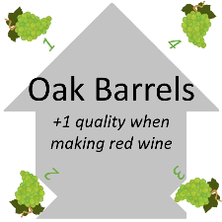After taking actions, the player upgrades their Grapes and Wines by rotating each Grape and Wine in their Tableau 90 degrees to the right if doing so results in a higher Quality. If a Grape or Wine is already at the highest Quality available on the card, then it simply remains at that highest available Quality and does not upgrade any further.

There is one constraint on upgrading Wine: A player may only have one Wine in their Tableau of Quality 6 or higher. If there is already a Wine of Quality 6 or higher in their Tableau, then any other Wine in their Tableau of Quality 5 may not be upgraded on that turn. The exception is if the player also has a “Cellar” in their Tableau, in which case the limit on Wines of Quality 6 or higher does not apply, and all Wines may be upgraded without restriction. On Wine cards, Qualities 6 and higher are circled as a reminder of this constraint.

## Discard if necessary

If the player has more than 14 cards total in their Hand and their Tableau (for example six cards in their Hand and nine cards in their Tableau for a total of 15), they discard cards from their Hand, their Tableau, or both in any combination to the Discard Pile until they have 14 cards total in their Hand and their Tableau.